PRN292_SE1166

THE COFFEE MANAGEMENT SYSTEM
Software Requirement Specification

Project Code: PRN292_Project
Document Code: PRN292_Project_Group4 – v1.0

Ho Chi Minh, Nov 5th 2017

Record of change

*A - Added M - Modified D - Deleted
Effective Date | Changed Items | A*  M, D | Change Description | New Version
5/11/2017 | Initial | a | Add project over view
5/11/2017 | Add functional requirement of Assets Management

SIGNATURE PAGE

ORIGINATOR: <Name> <Date>
<Position>

REVIEWERS: <Name> <Date>
<Position>

<Name, if it’s needed> <Date>
<Position>

APPROVAL: <Name> <Date>
<Position>
TABLE OF CONTENTS
1 Introduction 6
1.1 Purpose 6
1.2 Scope 6
1.3 Definitions, Acronyms, and Abbreviations 6
1.4 References 6
1.5 Overview 7
2 Overall Description 8
3 FUNCTIONAL Requirements 9
3.1 <The actors> 9
3.2 <The use cases> 9
3.3 <Use Cases Diagram> 9
3.3.1 <Functional Requirement one> 10
4 NON-FUNCTIONAL Requirements 11
4.1 Usability 11
4.2 Reliability 11
4.3 Performance 12
4.4 Supportability 12
4.5 Design Constraints 12
4.6 On-line User Documentation and Help System Requirements 12
4.7 Purchased Components 13
4.8 Interfaces 13
4.9 Licensing Requirements 13
4.10 Legal, Copyright, and Other Notices 13
4.11 Applicable Standards 14
5 Supporting Information 15

Introduction
Description of cafe management: a system to manage activities in a coffee shop automatically, with included functions: manage staff, manage menu, create order and checkout order.

Purpose
To make clear of what functions the system is responsible for.

Scope
Apply for almost any coffee store in the city with medium or upper scale.

Definitions, Acronyms, and Abbreviations
N/a

References
Template: 06be-BM/PM/HDCV/FSOFT v1/1
Initial data: www.thecoffeehouse.com/

Overview
N/a

Overall Description
1. Employee management:
• The shop owner logs into the system with the Admin privileges to use this function
• Include new employees, edit basic information, and deactivate any employee
• Additional editing activities record the time
2. Menu Management:
• The shop owner logs into the system with the Admin privileges to use this function
• Include new additions to a dish / drink, edit information, deactive an item out of the menu but excludes deletions.
• The editing activities record the time
3. Category Management:
• The shop owner logs into the system with the Admin privileges to use this function
• Include new categories, edit categories, add menus to the corresponding category, and deactivate a category
• The editing activities record the time
4. Create invoices:
• Shop staff log into the system to use this function
• Includes menu item picking, quantity filling, customer information entry, unpaid order adjustment, and bill payment.
• Time is recorded automatically
5. Invoice statistics:
• List bills for a specific time period (from day to day)
• View favorite menus (sorted by category)
• View the least popular menu (ranked by category)
• View total sales of invoices, average revenue on total invoices
• See the total take-away bill, total bill back to the shop

FUNCTIONAL Requirements

<The actors>
# | Main functions | Manager | Saler
1 | Login | x | x
2 | Logout | x | x
3 | View credit | x | x
4 | Create order |  | x
5 | Manage staffs | x
6 | Export statistic | x
7 | Manage products | x

<The use cases>

System Functions | Main Use Cases | Use Case #
Login
 | Login | UC_1.1
Logout
 | Logout | UC_1.2
View credit
 | ViewAbout | UC_1.3
Create order
 | AddNewOrder | UC_2.1
 | ReviseOrder | UC_2.2
 | CheckoutOrder | UC_2.3
Manage staffs
 | AddNewStaff | UC_3.1
 | SearchStaff | UC_3.2
 | UpdateStaffInfo | UC_3.3
 | DeactiveStaff | UC_3.4
Export statistic
 | ViewOrdersByDate | UC_4.1
 | ViewIncomeByDate | UC_4.2
 | ViewMostPopularMenuByDate | UC_4.3
 | CountOrderTypes | UC_4.4
Manage products
 | AddNewCategory | UC_5.1
 | UpdateCategoryInfo | UC_5.2
 | DeactiveCategory | UC_5.3
 | AddNewMenu | UC_5.4
 | UpdateMenuInfo | UC_5.5
 | DeactiveMenu | UC_5.6

<Use Cases Diagram>
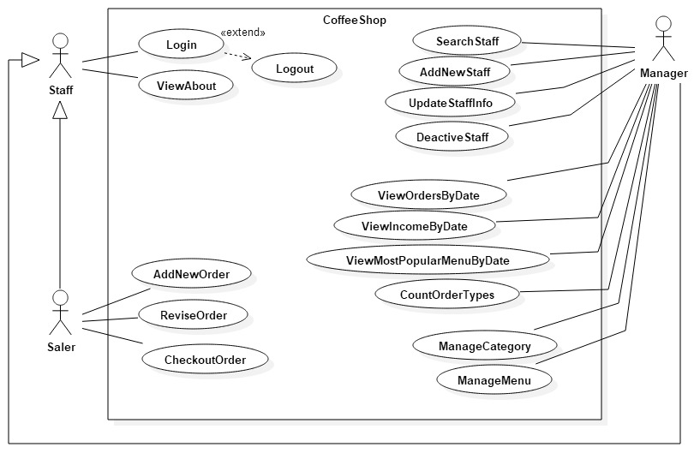

<Functional Requirement one>

<Overview Sequential Operations>
Add a new staff
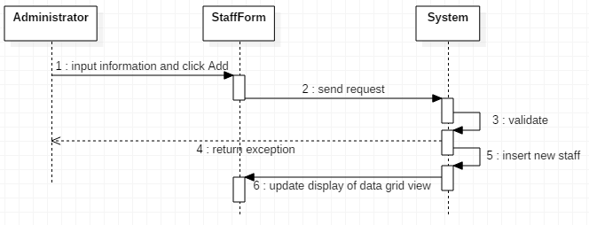

Author | Vo Gia Vu
Use Case Name | Add new staff
Actors | Administrator
Description | Administrator want to add new staff
Requirements
Pre-conditions | Login as Administrator
Post-conditions
Basic flow | Actor Actions:  1. Actor click on menu item HR and choose Staff Management on menu bar  3. Actor inputs information and click ‘Add’ button [Exception 1] [Exception 2] [Exception 3] [Exception 4] | System Responses:  2. System display Staff Form with following control:  - ‘Staffs Info’ data grid view  - ‘Username’ text box  - ‘Password’ text box  - ‘Confirm Password’ text box  - ‘Name’ text box  - ‘Birthday’ date time picker  - ‘Address’ text box  - ‘Join Date’ date time picker  - ‘Gender’ group radio box:  + ‘Male’ radio box  + ‘Female’ radio box  - ‘Phone’ mask text box  - ‘Email’ text box  - ‘Role’ combo box:  + ‘Administrator’  + ‘Staff’  - ‘Search Value’ text box  - ‘Search’ button  - ‘Add’ button  - ‘Update’ button  - ‘Delete’ button  5. System checks the information [Exception 5]  6. Add new staff into database and display in grid view
Alternative flow
Exception | Actor Actions:  [Exception 1]  1. Actor left ‘Username’ blank  [Exception 2]  1. Actor left ‘Password’ blank  [Exception 3]  1. ‘Confirm Password’ is different from ‘Password’  [Exception 4]  1. ‘Email’ is not empty and invalid format  [Exception 5]  1. ‘Username’ is duplicated | System responses:  2. System show a message box: “Username is required”  2 System show a message box: “Password is required”  2. System show a message box: “Cofirm is not match Password”  2. System show a message box: “Email is invalid”  2. System show a message box: “Error! Username is existed! Canceling request”

- Update staff information
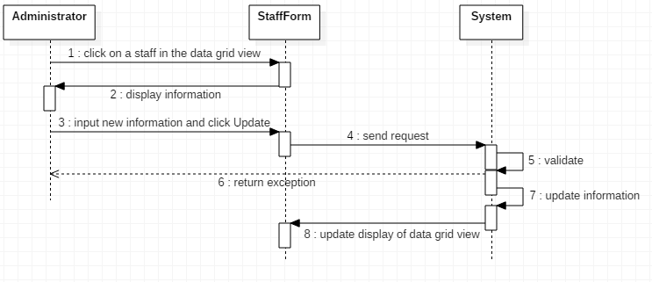
Author | Vo Gia Vu
Use Case Name | Update staff information
Actors | Administrator
Description | Administrator want to modify staff information
Requirements
Pre-conditions | Login as Administrator and open Staff Form
Post-conditions
Basic flow | Actor Actions:  1. Actor click on a staff information on data grid view  4. Actor modify information on text boxes and can click ‘isActive’ check box in data grid view, then click ‘Update’ button [Exception 1] [Exception 2] [Exception 3] | System Responses:  2. System get information of staff and fill in control text boxes  3. System disable ‘Username’ text box  5. System update new information for staff and display in data grid view
Alternative flow
Exception | Actor Actions:  [Exception 1]  1. Actor left ‘Password’ blank  [Exception 2]  1. ‘Confirm Password’ is different from ‘Password’  [Exception 3]  1. ‘Email’ is not empty and invalid format | System responses:  2 System show a message box: “Password is required”  2. System show a message box: “Cofirm is not match Password”  2. System show a message box: “Email is invalid”

- Delete staff
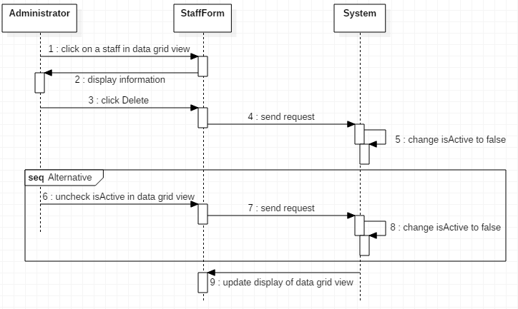
Author | Vo Gia Vu
Use Case Name | Delete staff
Actors | Administrator
Description | Administrator want to delete a staff
Requirements
Pre-conditions | Login as Administrator and open Staff Form
Post-conditions
Basic flow | Actor Actions:  1. Actor click on a staff information on data grid view  4. Actor click ‘Delete’ button [Alternative 1] | System Responses:  2. System get information of staff and fill in control text boxes  3. System disable ‘Username’ text box  5. System uncheck ‘isActive’ of this staff in database
Alternative flow | Actor Actions:  [Alternative 1]  1. Actor uncheck ‘isActive’ check box in data grid view | 2. System uncheck ‘isActive’ of this staff in database
Exception

Search staff
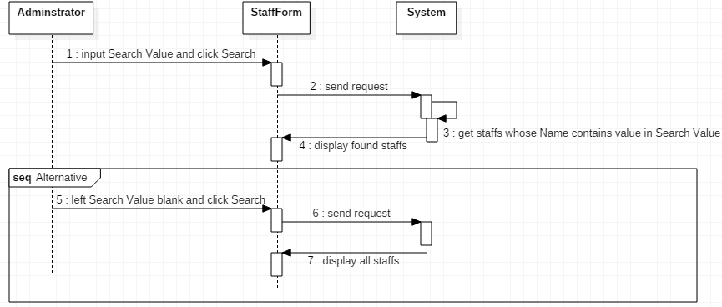

Author | Vo Gia Vu
Use Case Name | Search staff
Actors | Administrator
Description | Administrator want to search a staff
Requirements
Pre-conditions | Login as Administrator and open Staff Form
Post-conditions
Basic flow | Actor Actions:  1. Actor input name of staff into ‘Search Value’ text box and click ‘Search’ button [Alternative 1] | System Responses:  2. System display staff whose name contain value in ‘Search Value’ text box in data grid view
Alternative flow | Actor Actions:  [Alternative 1]  1. Actor left ‘Search Value’ blank and click ‘Search’ button | 2. System display all staffs in data grid view
Exception

NON-FUNCTIONAL Requirements

Usability
The system must be easy to use, have friendly GUI, take no time to train new user to get used to the operations.
The interaction must be capable with further upgradation for touch-screen operations.

Reliability
Availability—the percentage of time available must be 100% of all the time the coffee store works.
Mean Time Between Failures (MTBF) is about 6-8 months of operations.
Mean Time To Repair (MTTR) is about 1-2 days of working.

Performance
Response time for a transaction must be under 3 seconds

Supportability
The creation team is always ready for supporting activities

Design Constraints
The system must be created in .NET Window Form framework
Database used in system must be Microsoft SQL Server version 2008 upper.
Connection to database must uses ADO.NET framework to get access.

On-line User Documentation and Help System Requirements
N/a

Purchased Components
N/a

Interfaces

User Interfaces
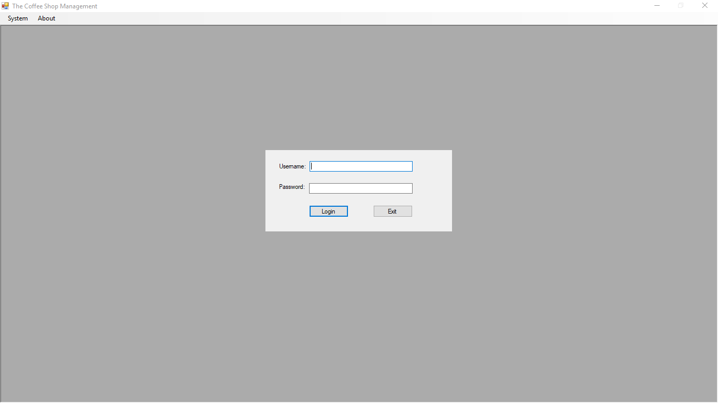
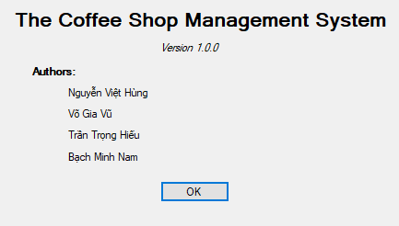
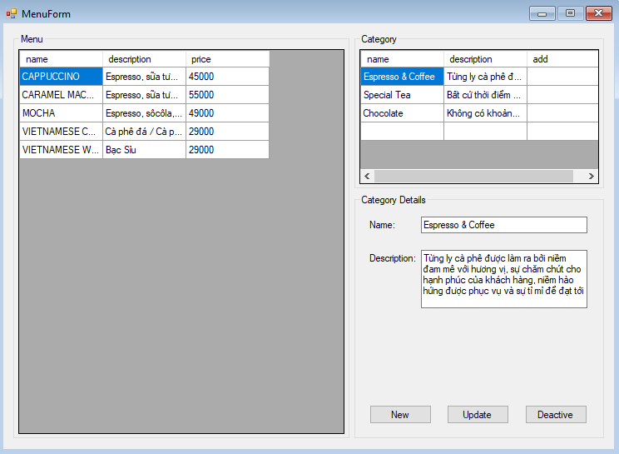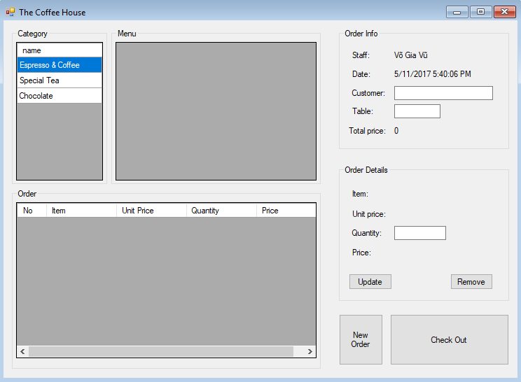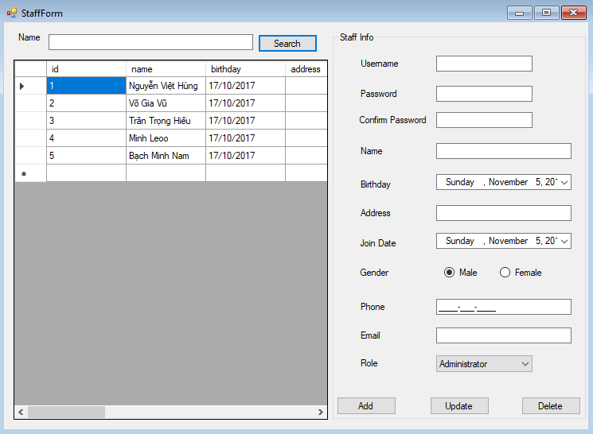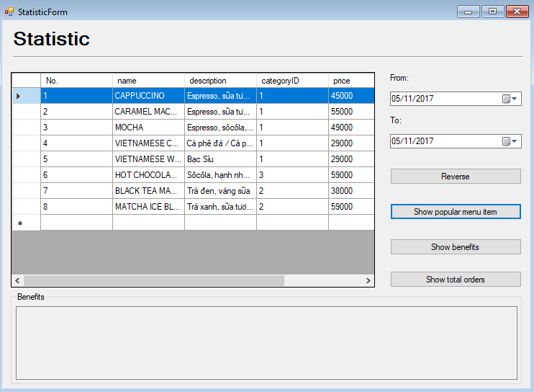

Licensing Requirements
N/a

Legal, Copyright, and Other Notices
N/a

Applicable Standards
N/a

Supporting Information
N/a

